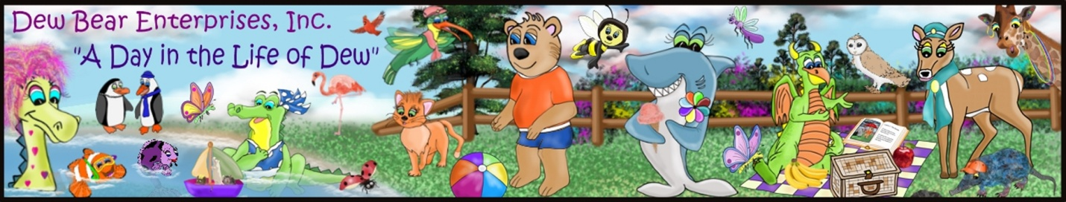

To place an order: print this form, fill it out, scan it, and e-mail it to dewbear@mindspring.com.
Upon receipt, we’ll e-mail you an invoice. You can pay by check or pay-pal (or you can call 336-525-2274 to place an order by phone). Orders will be shipped as quickly as possible.
Shipping charges will apply. If placing an order for delivery in North Carolina, sales tax will be added.
Which book(s) would you like and how many?
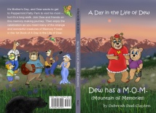
Dew Series - Book 1 – Dew has a M.O.M. (Mountain of Memories)

Special gift … every order will include a Dew Bear bookmark!
Paperback ($6.99 each) Qty
Hardcover ($13.99 each) Qty

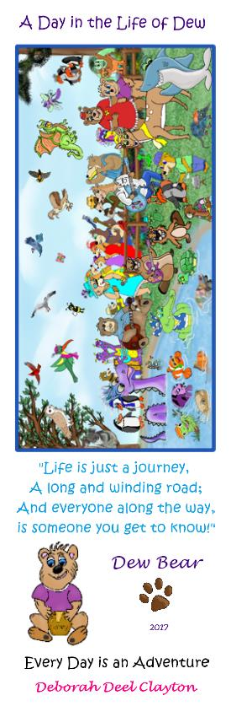
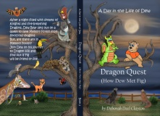
Dew Series Book 2 – Dragon Quest (How Dew Met Fig)

Paperback ($7.99 each) Qty
Hardcover ($14.99 each) Qty

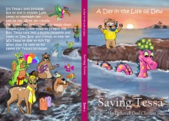
Dew Series Book 3 – Saving Tess

Paperback ($7.99 each) Qty
Hardcover ($14.99 each) Qty

Dew Series Book 4 – A Penny for Your Thoughts

Paperback ($7.99 each) Qty
Hardcover ($14.99 each) Qty

Dew Series Book 5 – Sharky’s Special Day

Paperback ($7.99 each) Qty
Hardcover ($14.99 each) Qty

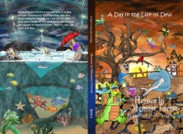
Dew Series Book 6 – Heroes In Memory Forest

Paperback ($7.99 each) Qty
Hardcover ($14.99 each) Qty

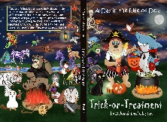
Dew Series Book 7 – Trick-or-Treatment

Paperback ($7.99 each) Qty
Hardcover ($14.99 each) Qty

Dew Series Book 8 – Small can be the Right Size

Paperback ($7.99 each) Qty
Hardcover ($14.99 each) Qty

Book choices are continued on next page

Magic Pencil (a non-Dew Bear series book)

Paperback ($4.99 each) Qty
(Not available in Hardcover)

My Name is Willa (a non-Dew Bear series book)

Hardcover ($12.00 each) Qty Qty
(Not available in paperback)

Fantastical Voyage (a non-Dew Bear series book)

Paperback ($8.99 each) Qty
Hardcover ($15.99 each) Qty

Your Contact Information:

Name Phone #

e-mail address

Mailing address

Payment Preference: Paypal Personal Ck (ck orders will be shipped once check is received)
Special Instructions:

If you would like the book(s) personalized, please print the child’s name(s) in the special instructions.
How did you hear about Dew Bear?

Thank you for your interest in the books published by Dew Bear Enterprises Inc.

